NETSHe & GNS3

**NETSHe Lab Ltd.**

INSTALLATION AND CONFIGURATION GUIDE

**Ver. 1.0**

**December, 2019**

Introduction 1

General remarks about installation, configuration and using GNS3 on Windows and Linux 2

Installation and configuration GNS3 on computer under OS Windows. 3

Virtual application installation 4

GNS-VM configuration 6

Import NETSHe appliance 6

Working with NETSHe devices in GNS3 8

Working with existing projects or projects created on other computers. 9

Remarks for VirtualBox using 11

Installation, configuration, and working with GNS3 on Linux computer. 13

# Introduction

NETSHe Lab has been developing firmware for network equipment and software for network service providers and telecommunication companies. Operating system NETSHe as a main focus of software could be used for wide spectrum of network services and devices among which are:

* Full-fledged router with static and dynamic RIP/OSPF/BGP routing which could support in addition redundant connections and balancing;
* Tunnels based on IPIP, L2TP, PPPTP, PPPoE, GRE, OpenVPN, IPSec etc. with Layer2 / Layer3 data transmission;
* Full-fledged firewall;
* Possibility of building dynamic fully connected networks with encrypted connections (DM VPN);
* Working with cellular and wireless networks.

Cost and ownership reduction are always a top priority for NETSHe Lab company. Under this strategy we provide a single, unified Web-interface for all types of devices. That interface allows using the same skills and knowledge set for different devices. Being able to supervise the simplest device the user can work with more and more complicated devices with good productivity.

Clearly, another element of NETSHe Lab strategy for the total cost of ownership reducing is the providing tools for various tasks:

* entry training NETSHe course,
* participating in the educational process,
* simulation for possible application cases,
* for checking compatibility with devices by other manufacturers.

To decide the tasks above we offer to use well known network simulator GNS3, NETSHe simulation appliance and training project modules.

**What GNS3 is?**

Abbreviation means Graphical Network Simulator. It allows to create many network topologies just with your computer. The most often GNS3 using is as a test bench where user is able to check a network scheme or some applied technology. Indeed, GNS3 is not simulator but emulator.

An emulator allows to create a computer or device model and then run original software inside. All working device’s processes are emulated including CPU, RAM, I/O units. For example, GNS3 helps to create a Cisco router model and run the Cisco operating system IOS inside that router.

So GNS3 provides full-fledged routers, firewalls and service providers connecting equipment for training and testing.

**Why GNS3?**

* The first and main cause is that GNS3 ensures full functionality for emulated devices.
* Building heterogeneous networks. It means the user can join NETSHe, Cisco, Juniper, Mikrotik, CheckPoint etc. to the same scheme.
* Connecting a test lab with Internet or real networks / computers.
* GNS3 is free software.

To find out more is possible on the official Internet site [https://gns3.com](https://gns3.com/)

This document describes GNS3 installation and configuration process on computers under Windows and Linux operating systems. As well it depicts the universal image import procedure for devices under NETSHe OS. And finally, this document shows project examples by NETSHe Lab and tells how to create your own projects with NETSHe devices involved.

# General remarks about installation, configuration and using GNS3 on Windows and Linux

Installation, configuration and running GNS3 on Linux seems simpler and more useful due to embedded virtualization absent and using of genuine Linux features such as Qemu и KVM.

This document is not a complete guide of GNS3 working. To introduce user should watch GNS3 educational video course or read some of numerous written materials. E.g. we recommend some course from the developers’ team:

<https://www.youtube.com/watch?v=LvLGEKD-oqA>

<https://www.youtube.com/watch?v=R6fSub4ycTk>

<https://www.youtube.com/watch?v=anYw9pbAUiI> )

          In this document we describe special things which connected with GNS3 configuration for working with NETSHe. As well we show how to choose virtualization tool applicable for user’s tasks.

# Installation and configuration GNS3 on computer under OS Windows.

GNS3 is free software available to download from Internet site www.gns3.com. Windows installation is performed without any special characteristic. On the firstboot GNS3 will ask how to run server. If user has the only computer he should choose ‘local server’ ‘tcp:3080’. Later user can see and change that features with ‘Server’ options in ‘Preferences’ menu item.

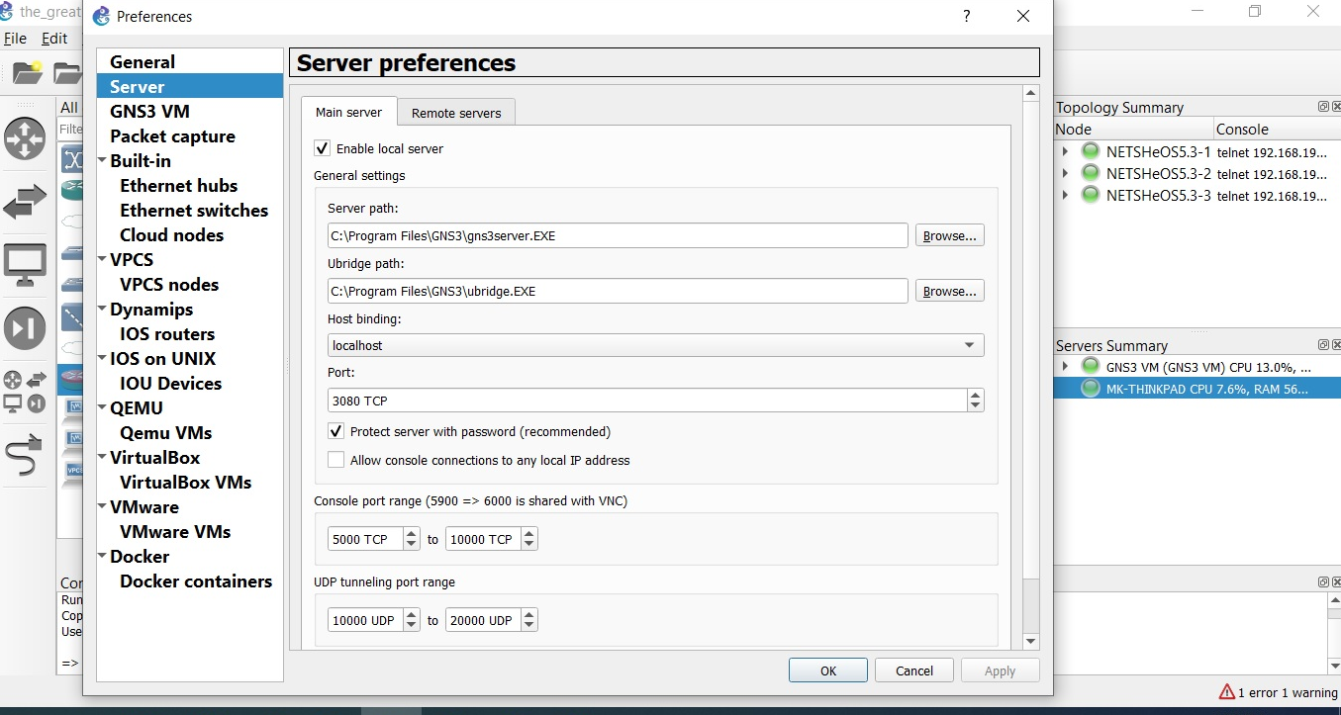

Caution! GNS3 is a robust application. Do not run other applications with resource-intensive activity the same time as GNS3.

## Virtual application installation

Windows and GNS3 together support several applications for virtualization such as VMWare Workstation, VirtualBox, and VMWare Player. Unfortunately, GNS3 under Windows supports embedded virtualization, so there is no any evidence of VMWare Player capability. As a result, we do not consider on VMWare Player in this document. Embedded virtualization for Oracle VirtualBox has been built recently mostly for AMD processors.

Caution!

NETSHe Lab insist on using VMWare Workstation for Windows, because that way provides maximum of simulator’s functionality and minimal resource consummation as well as minimal configuring actions by the user.

So, it is a good idea to use VMWare Workstation as virtualization platform. VMWare Workstation is not free software but it is available for 30 days trial period.

VMWare Workstation installation goes without special characteristic. During that process some network adapters (standard loopback) will be created they could be used in future for communication to the Internet, a user’s computer or network.

After VMWare Workstation installation (or after any virtualization installation) user should download GNS-VM virtual machine template from the site <https://www.gns3.com/software/download-vm>. Next user should start standard procedure of the template import and run a new virtual machine.

Before the virtual machine starting user should tick the check box ‘Intel-VT support’ in the virtual machine settings.

After machine starting user must ensure that GNS3 virtual machine has started successful.

User must press ‘ОК’ on dialog above and ensure that VM main menu appears. Next user should turn the virtual machine off by using main menu item ‘Shutdown’.

## GNS-VM configuration

GNS-VM could be connected to GNS3 with ‘Service’ options in ‘Preferences’ menu. User can choose essential options with drop-down lists which already include appropriate variants.

In case all configuration steps have been done properly GNS-VM machine starts automatically. User can see it in GNS3 interface at the right side in ‘Servers’ list.

## Import NETSHe appliance

Caution! Prior download netshe.gns3a file: <http://gw.stasoft.net/share/gns3/netshe.gns3a> or <http://netshe-lab.ru/files/gns3a/netshe.gns3a>

User should use ‘Files’ ->’Import Appliance’ menu item for import an appliance then choose the downloaded file netshe.gns3a.

The appliance will download NETSHe virtual machine image from NETSHe Lab site automatically. If user does not have Internet connection he must download VHD image <http://gw.stasoft.net/share/gns3/NETSHe-5.3-amd64.vmdk> or <http://netshe-lab.ru/files/gns3/NETSHe-5.3-amd64.vmdk> where 5.3 is NETSHe OS version which is valid at the moment. User is able to check necessary NETSHe OS version and .vmdk file consistency by viewing *.gns3a file, its [images] section.

After all action are performed user can see a new GNS3 device in device browser. It is Qemu VM with ‘NETSHe OS’ name.

After that it is possible to use NETSHe devices in any test projects just pull and drop it to the project’s window.

## Working with NETSHe devices in GNS3

All action user performs with NETSHe devices should be done like with Cisco System devices or other manufactures’ devices. Device’s context menu seems as standard one and console is connected through console application installed on the user’s computer.

It should be noted only integration GNS-VM by VMWare Workstation allows to get all NETSHe OS functionality in tests.

## Working with existing projects or projects created on other computers.

If NETSHe operating system is integrated to GNS3 environment it will be possible to work with existing projects. User could download test examples from <http://gw.stasoft.net/share/gns3/projects/>or <http://netshe-lab.ru/files/gns3/projects/> Project files have .gns3project extension and they are ready for further work.

User can open any project file in GNS3 even if the project is created under Linux operating system.

User has any working project without any adaptation and test behaviour is the same it was on the old computer. E.g. a device will work with the Internet through NIC on a new computer if device is connected to the Internet by design on the old computer.

Opened project inherits all features from the original project. For example, on the picture below VPCs do not have IP addresses adjusted so they still unavailable for ping.

## Remarks for VirtualBox using

How it is described above user has full functional GNS3 lab on Windows computer only by using VMWare Workstation. It depends on coworking GNS-VM and Qemu. In case future version GNS3 is able to provide such coworking based on the other virtual platform that NETSHe will work in new environment automatically.

Unfortunately at the moment, the running of GNS-VM on Virtual Box is possible (see picture above), but Qemu returns empty set as a reply for import NETSHe appliance. It means that NETSHe will be unavailable as Qemu virtual machine.

User may avoid of it by the using of import procedure for VirtualBox virtual machines.

However, test functionality will be strong restricted. It happened due to GNS3 restriction:

* User can use any VirtualBox virtual machine once per a project. If user try to use the same virtual machine twice he will see corresponding error message.
* The second or the third NETSHe devices may be included in the same project if they be as another virtual machines. It is needed to create a virtual machine clone every time. Of cause, this way to use many NETSHe devices could not be efficient and effective.

In view of the above we recommend VirtualBox using only for starting training with NETSHe operating system.

# Installation, configuration, and working with GNS3 on Linux computer.

This document describes GNS3 version 2.2.x and Ubuntu based distributives versions 16.04/18.04.

Unfortunately, Ubuntu 16.04/18.04 and derivatives have an old GNS3 versions in their repositories. In the Internet there are many GNS3 installation manuals for vary Linux distributives including manuals about source-code based installations.

We do not use a source-code base and we would advise to install GNS3 from PPA repository. Active Internet connection is needed. Enter following console commands:

sudo apt-get update

sudo apt-get upgrade

sudo apt-get install qemu qemu-kvm

Next user must accept all update requests for all system software on the computer:

sudo add-apt-repository ppa:gns3/ppa

sudo apt-get update

sudo apt-get install gns3-gui

Every command takes some time for application download and installation. At the end of installation operating system ask permission for packets capture and GNS3 execution under non-privileged user accounts. User should click ‘Yes’ to reply for both questions.

If user has a plan to include Cisco System devices to GNS3 projects he should run following commands:

sudo dpkg --add-architecture i386

sudo apt-get update

sudo apt-get install gns3-iou

Next user should restart the computer and after that run GNS3. At the first run GNS3 will ask several questions.

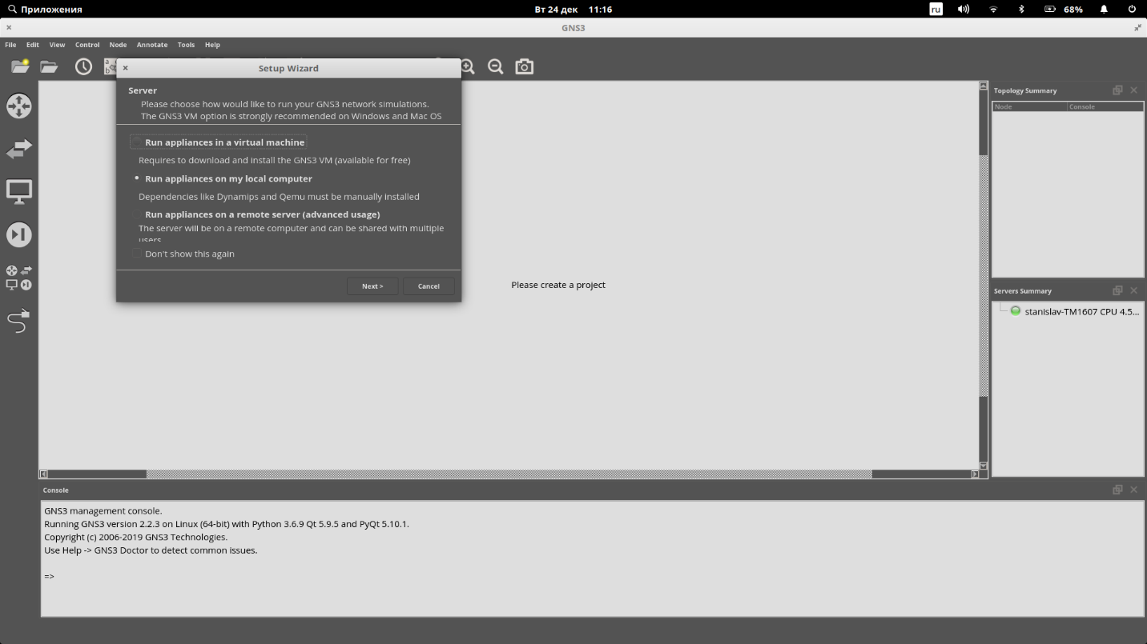

In case above user must choose «Run application on my local computer». And on next dialog user must accept GNS3 choice.

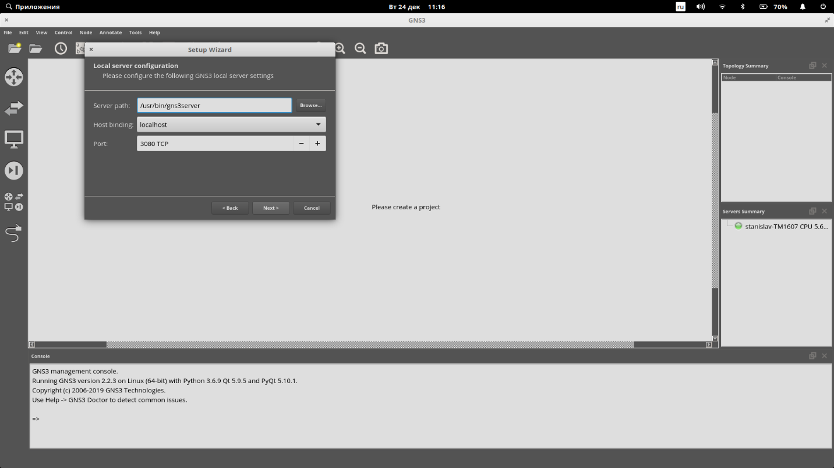

If everything is OK GNS3 will inform that it is connected to local server successfully. GNS3 will find Qemu automatically.

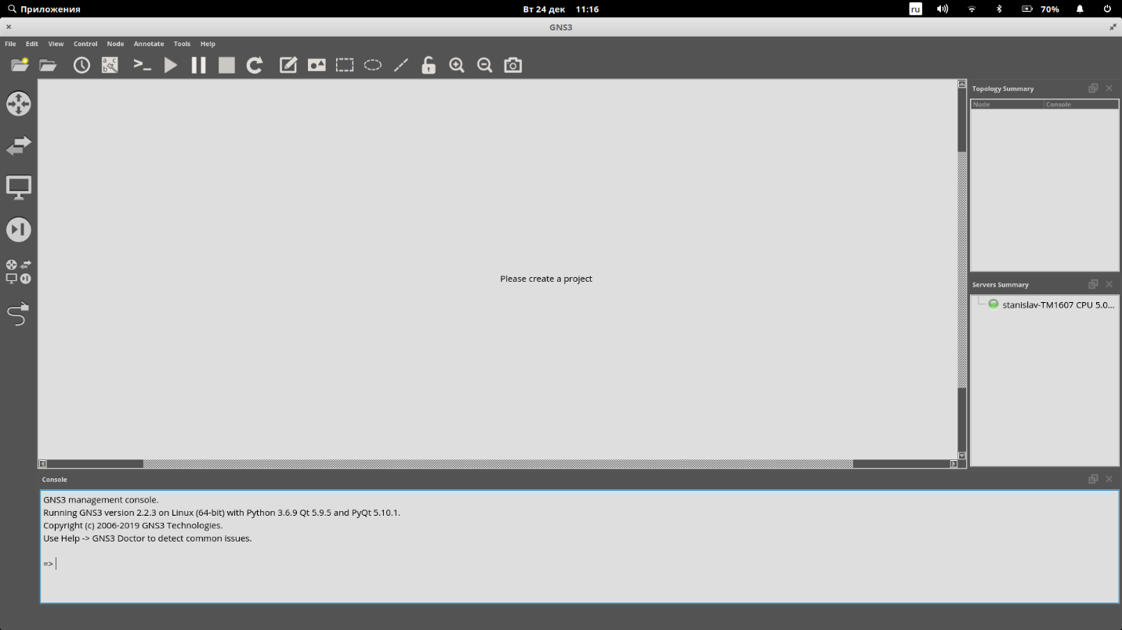

Installation and configuration have been finished. Next step is NETSHe appliance import. To do it user should click ‘File’ -> ‘Import appliance’ and find netshe.gns3a file location.

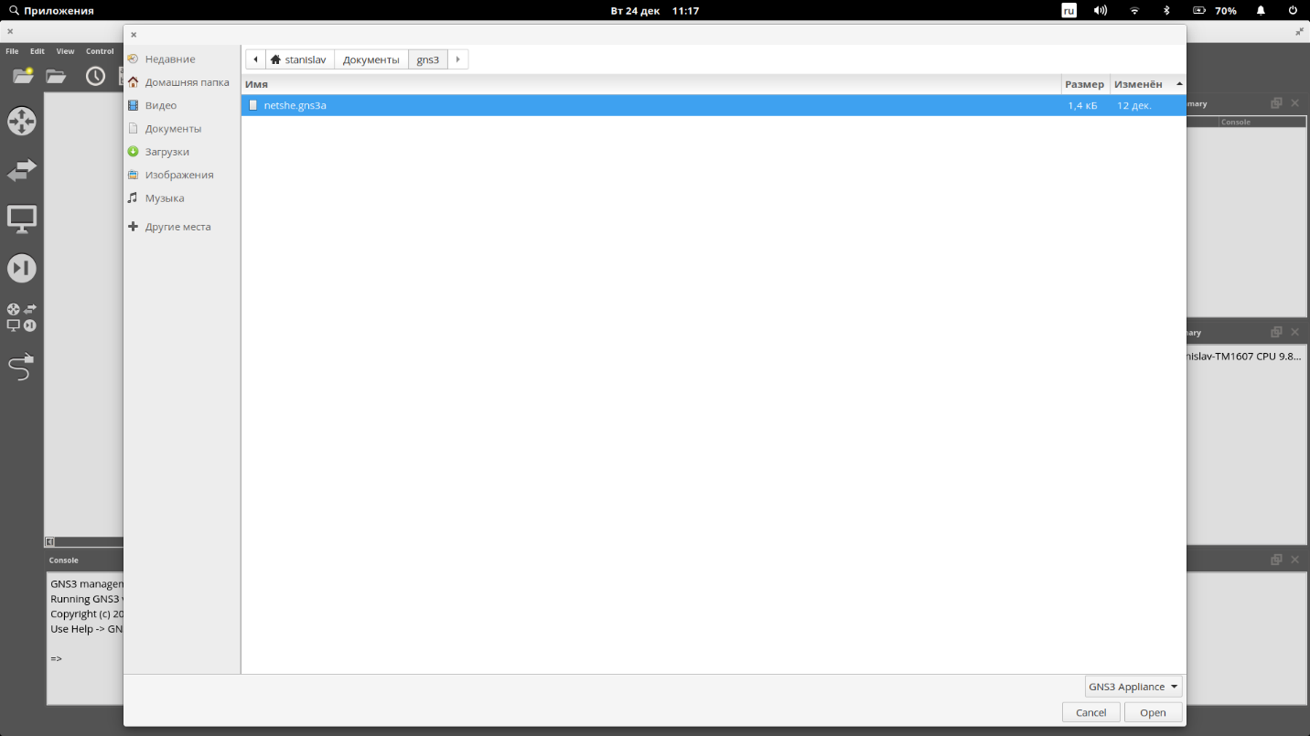

Then user should do import wizard steps. In case below NETSHe virtual machine image is located in the same folder as .gns3a file.

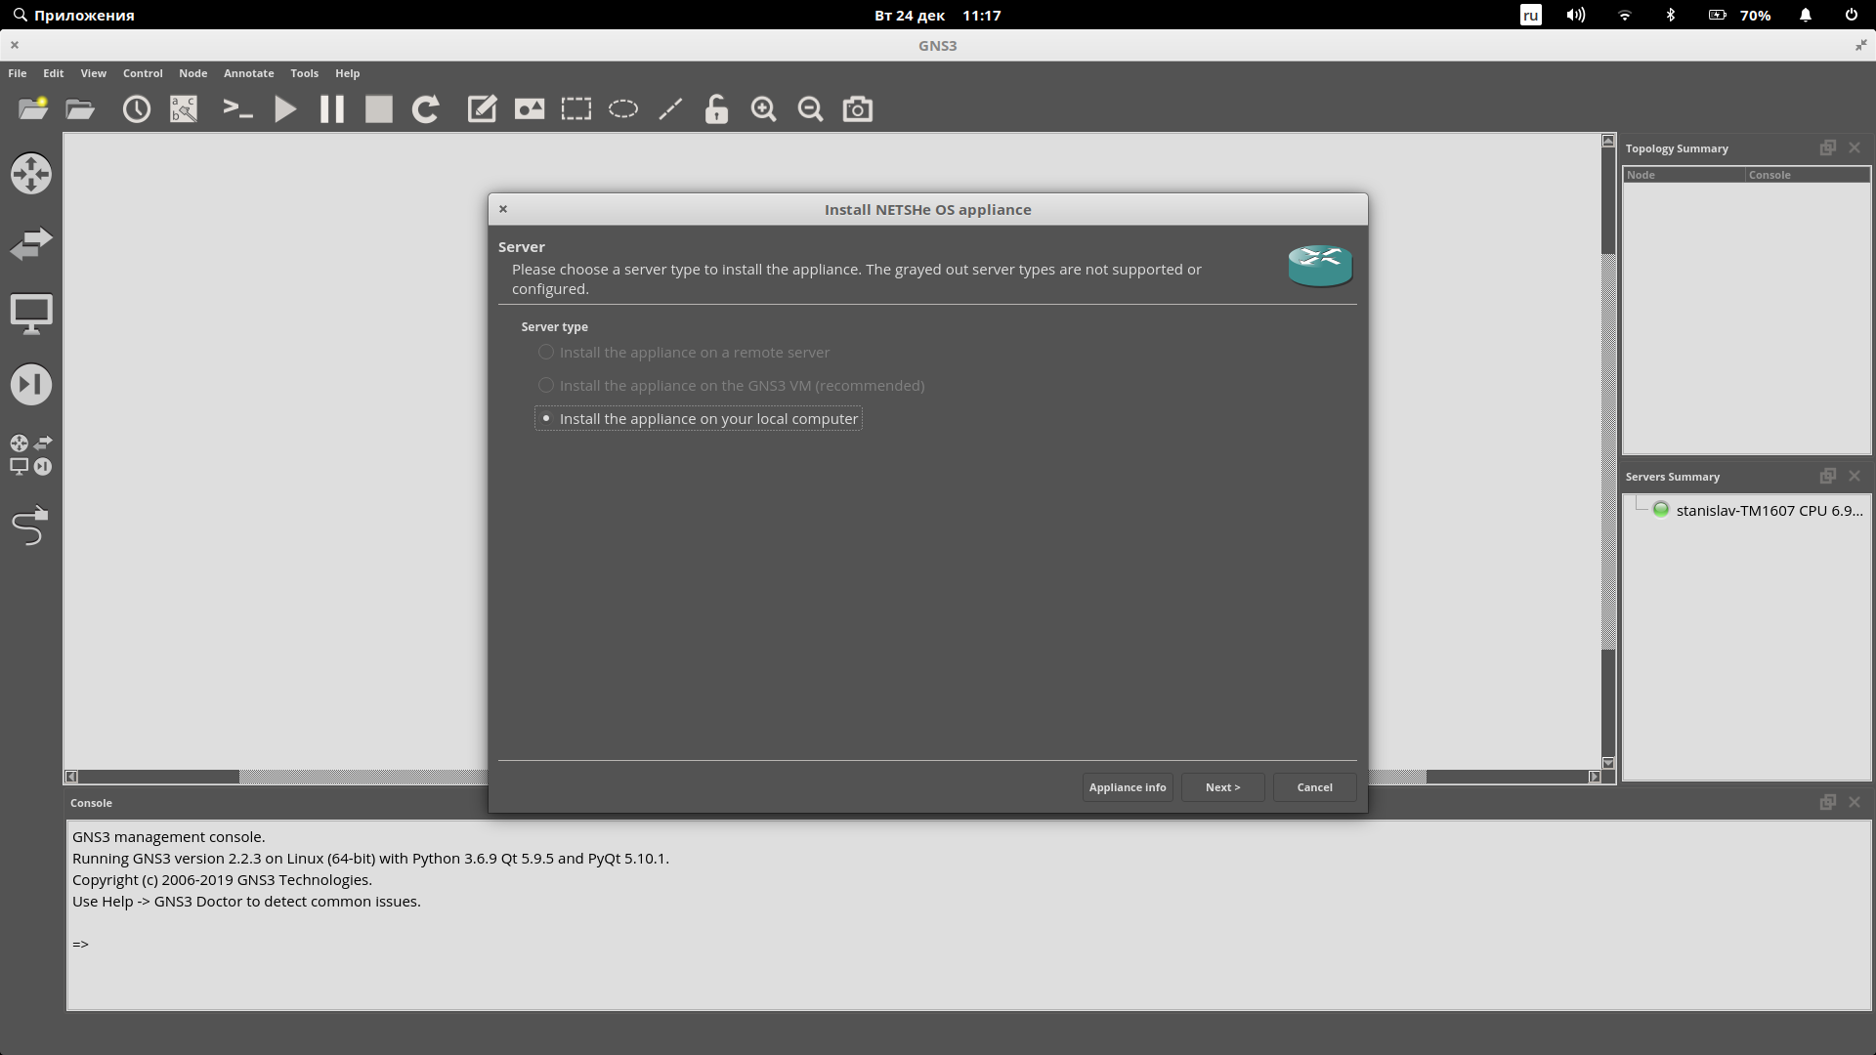

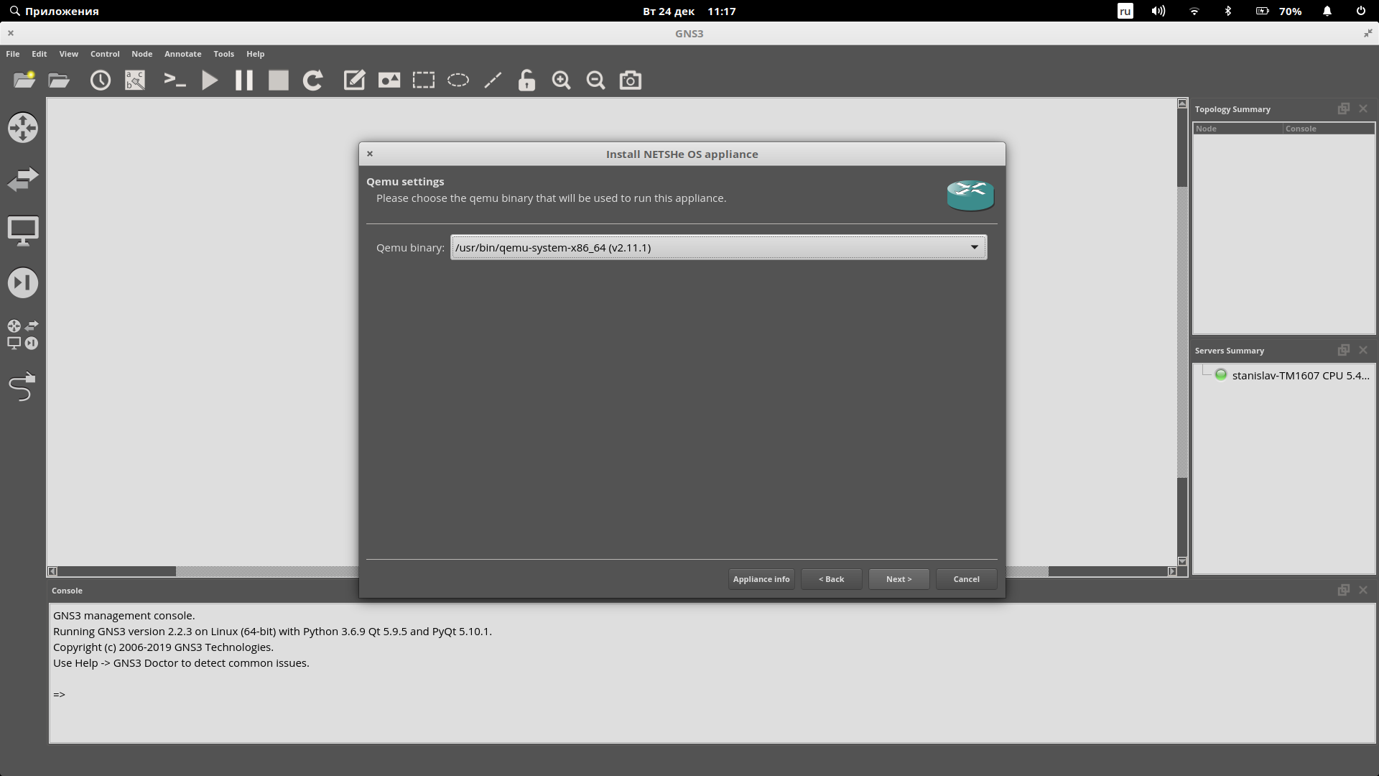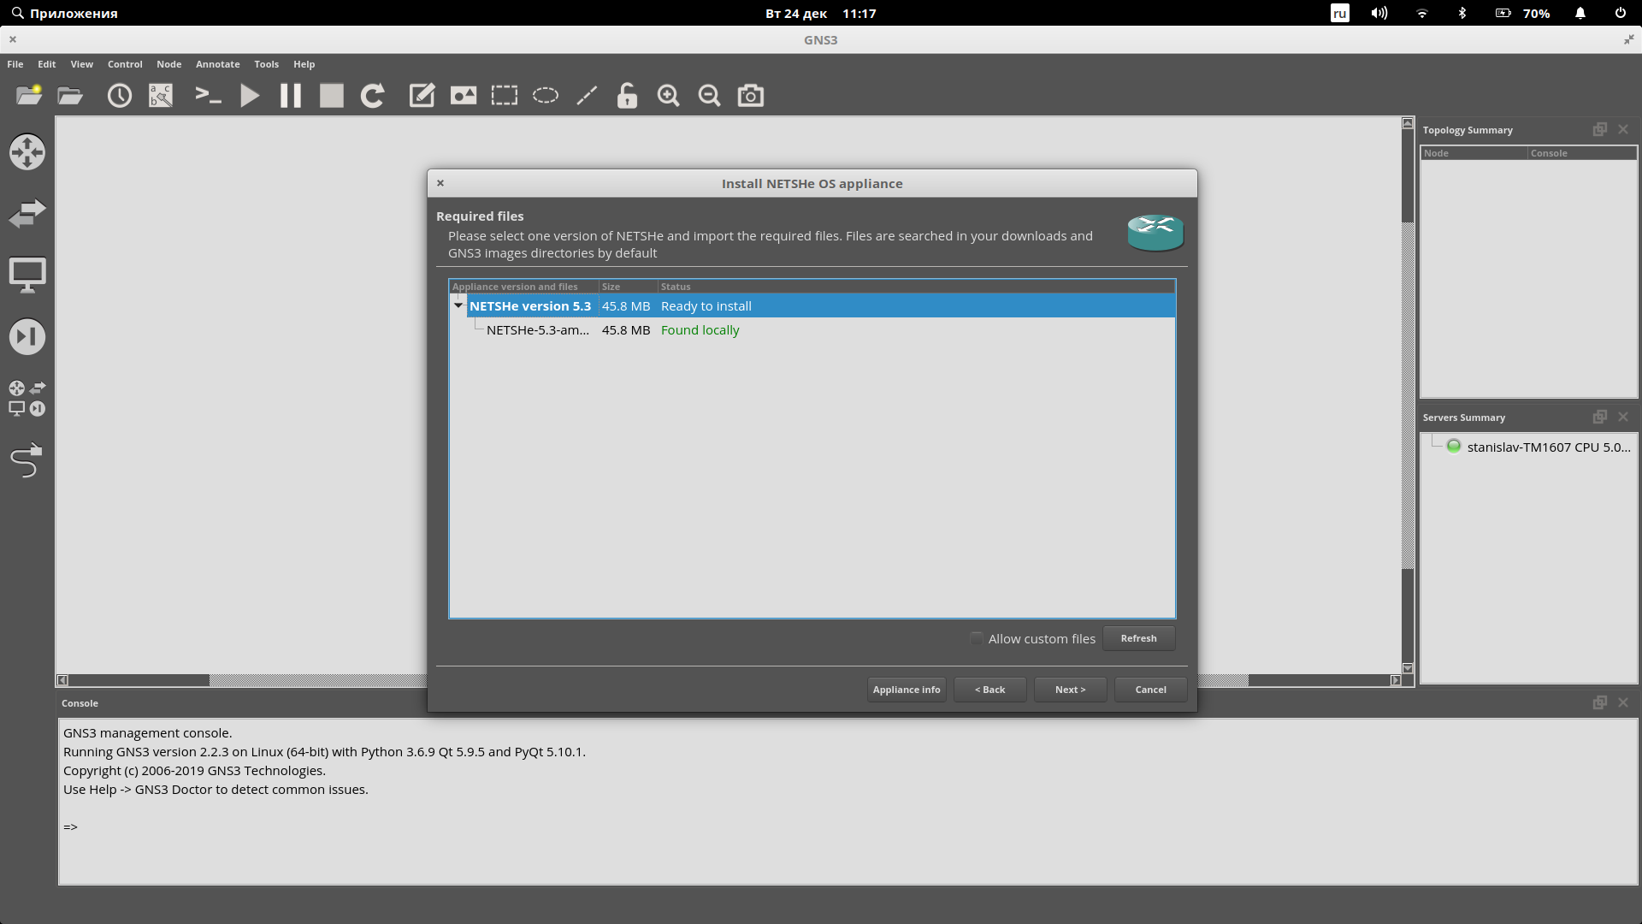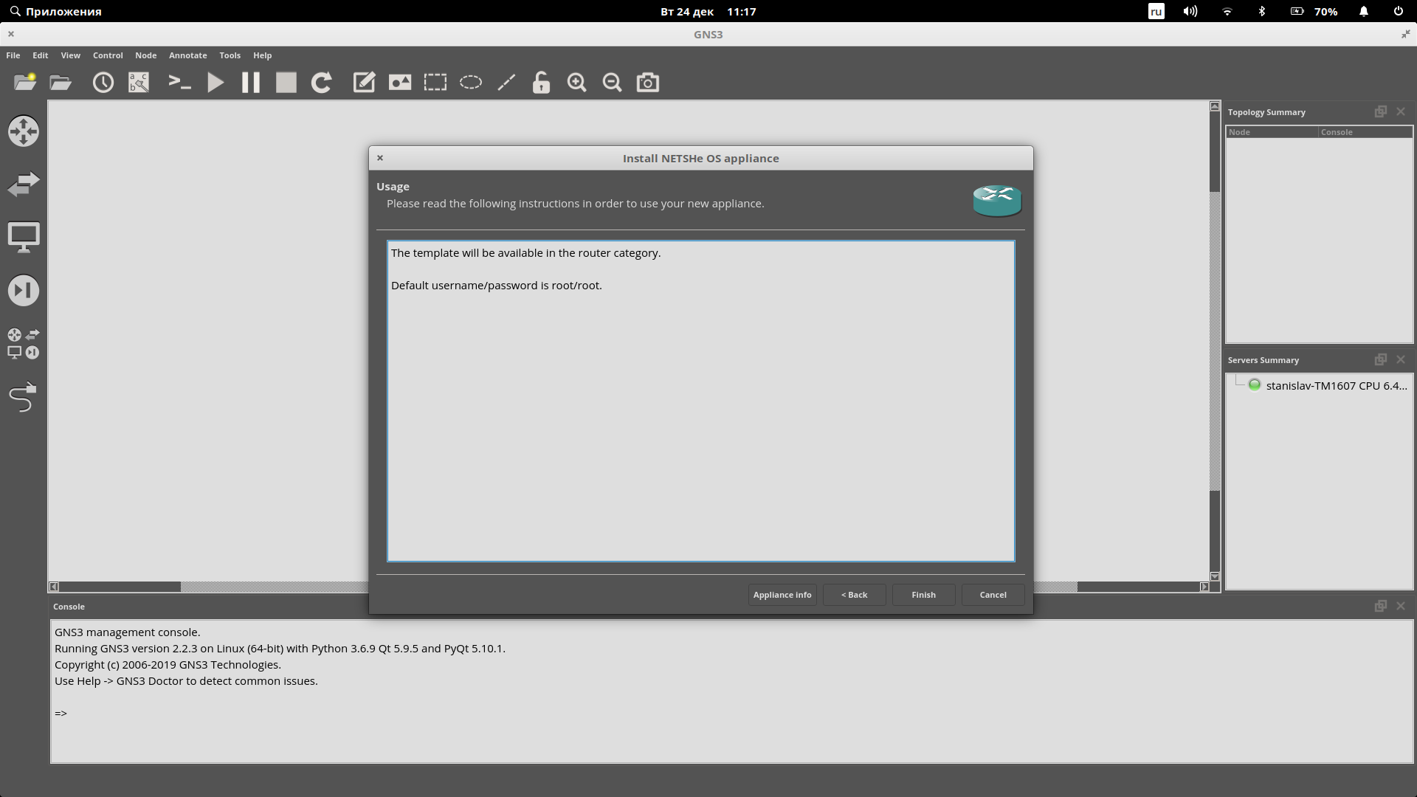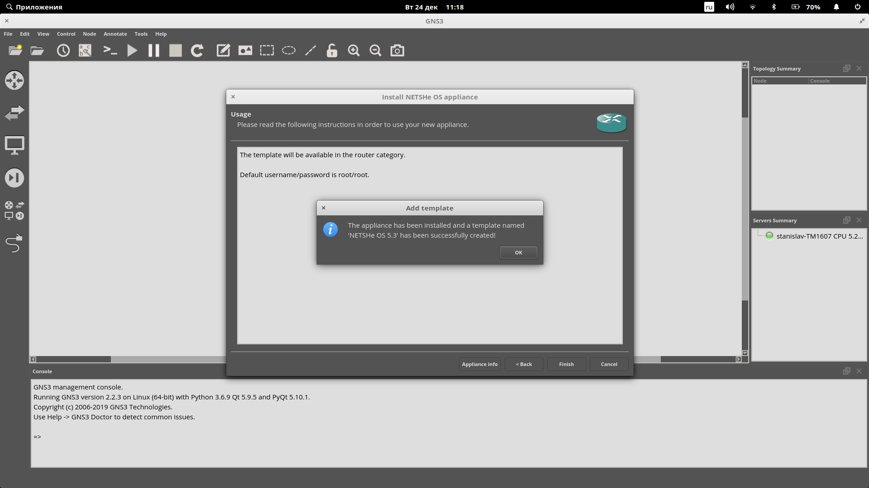

Appliance import has been finished. User must go to the first project creation.

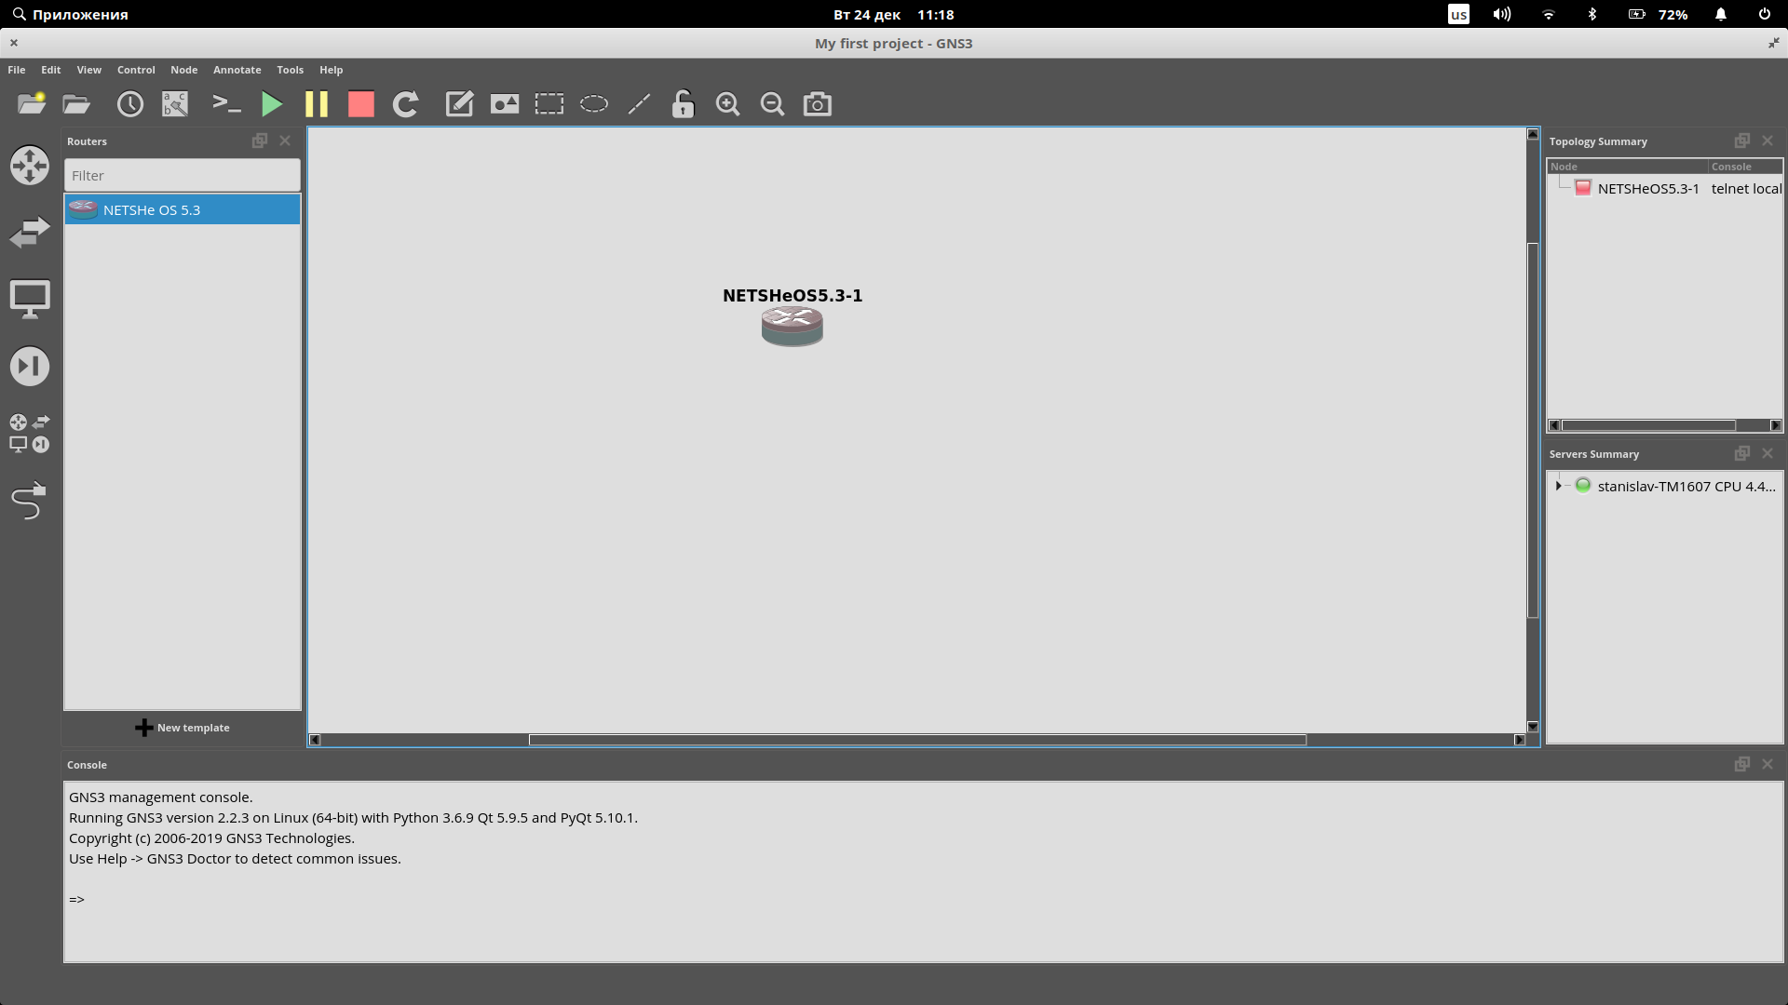

User should choose ‘File’->’New blank project’. Then user must click the first icon from the column list at the left, pull NETSHe OS device icon, and drop it on the project window.

Following are some remarks about NETSHe device image which is used in GNS3:

* NETSHe device supports up to 5 Ethernet interfaces named еth0- eth4.
* eth0 is WAN interface to uplink router. It has DHCP-client running by default. All incoming traffic is drop except ICMP and Web-traffic (TCP port 5556).
* eth1 is LAN interface. It has 192.168.1.1/24 IP address linked and running DHCP-server by default. All inbound traffic is allowed. NAT to eth0 is configured.
* eth2 is DMZ interface. It has 172.16.0.1/16 IP address linked. NAT for DMZ zone is configured: from WAN/ LAN TCP port 80 to 172.16.0.2:80 and UDP port 53 to 172.16.0.3:53; from DMZ to WAN/LAN all ports.
* Web-access TCP port 5556:

full permission credentials is superuser/abC123dEf_ ;

restricted access is root/root;

SSH access from LAN zone login and password are root/root.